ASSIGNMENT-6

Name: Gopika J Reg No:192324032

1.Maximum XOR of Two Non-Overlapping Subtrees:

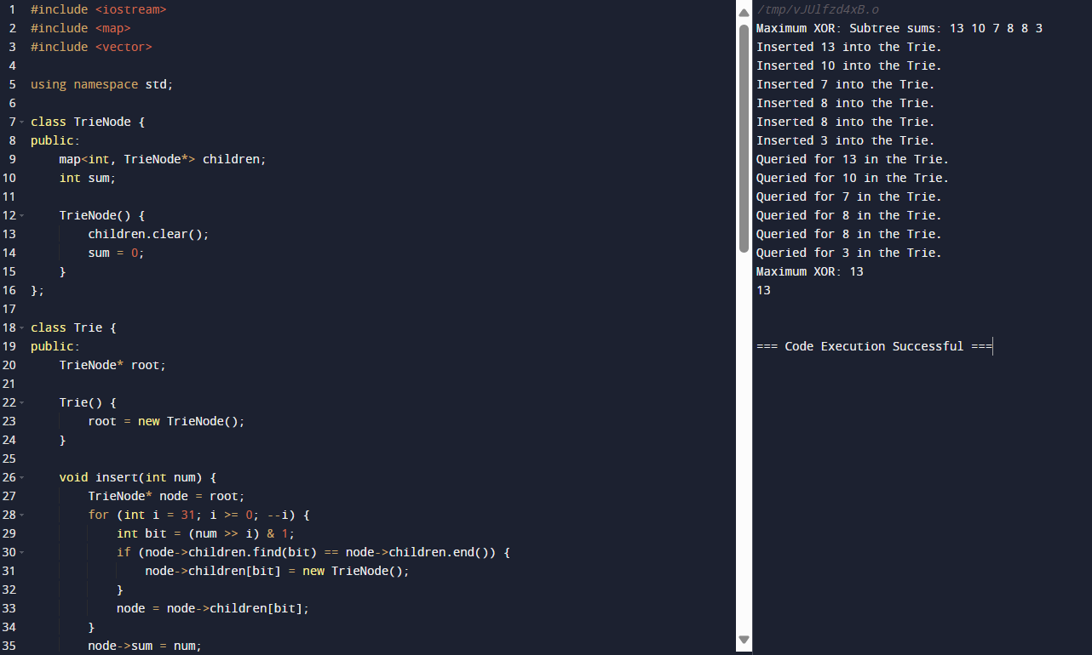

2. Form a Chemical Bond

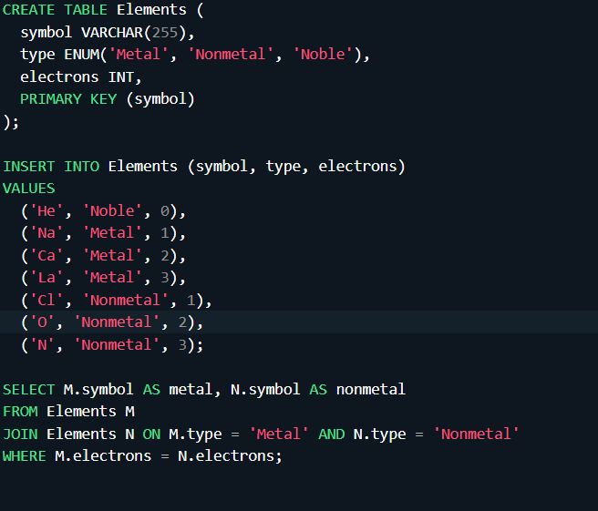

3.Minimum Cuts to Divide a Circle

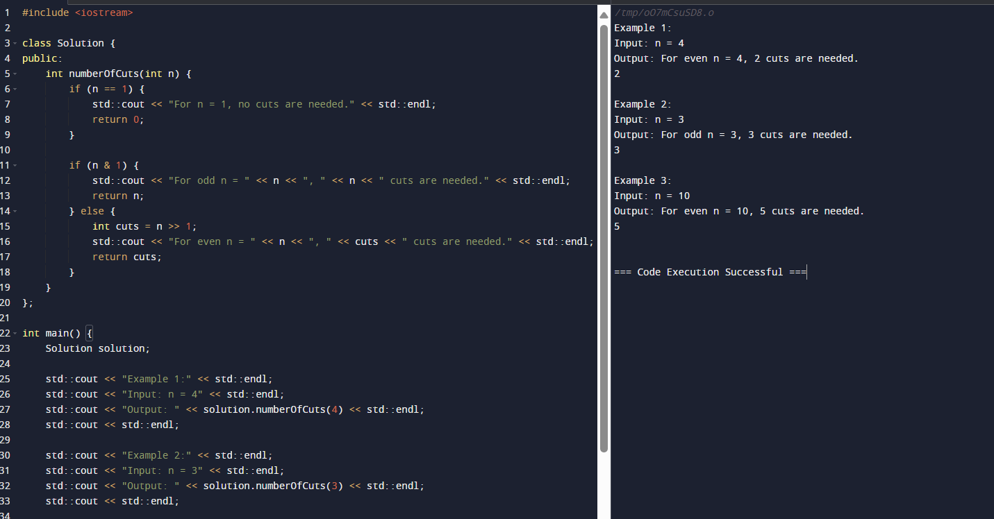

4.Difference Between Ones and Zeros in Row and Column

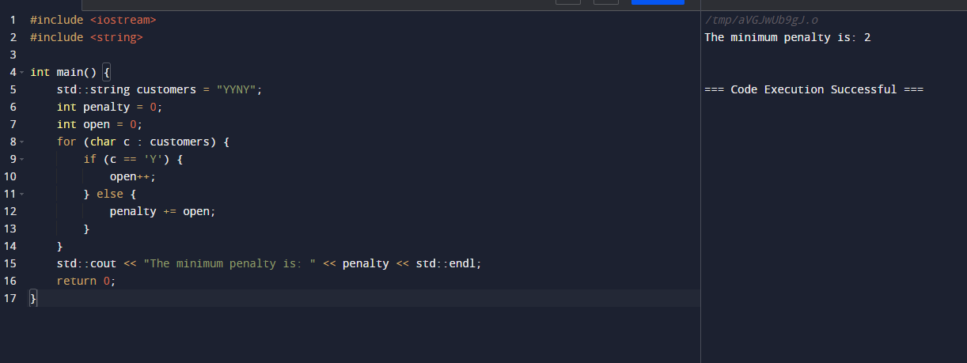

5.Minimum Penalty for a Shop



6.Count Palindromic Subsequence

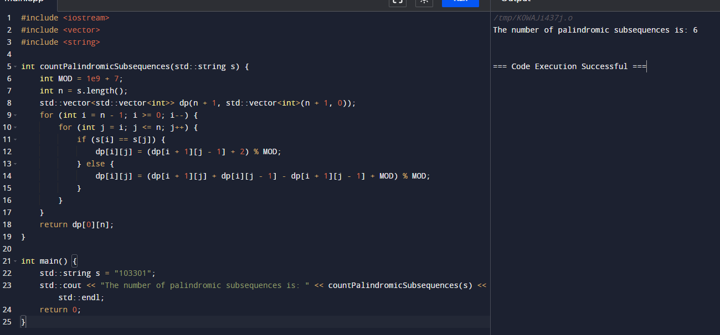

7.Find the Pivot Integer

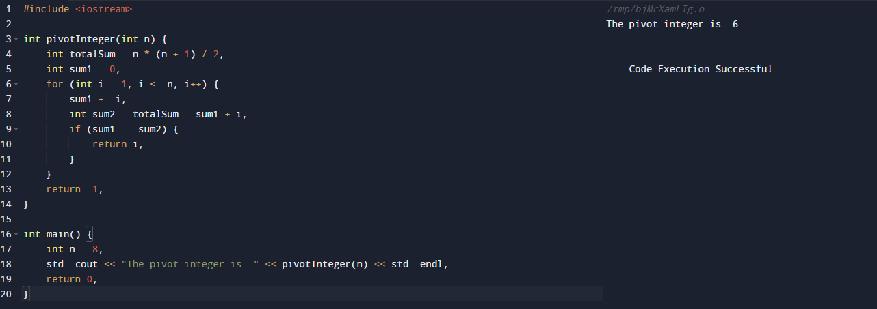

8. Append Characters to String to Make Subsequence

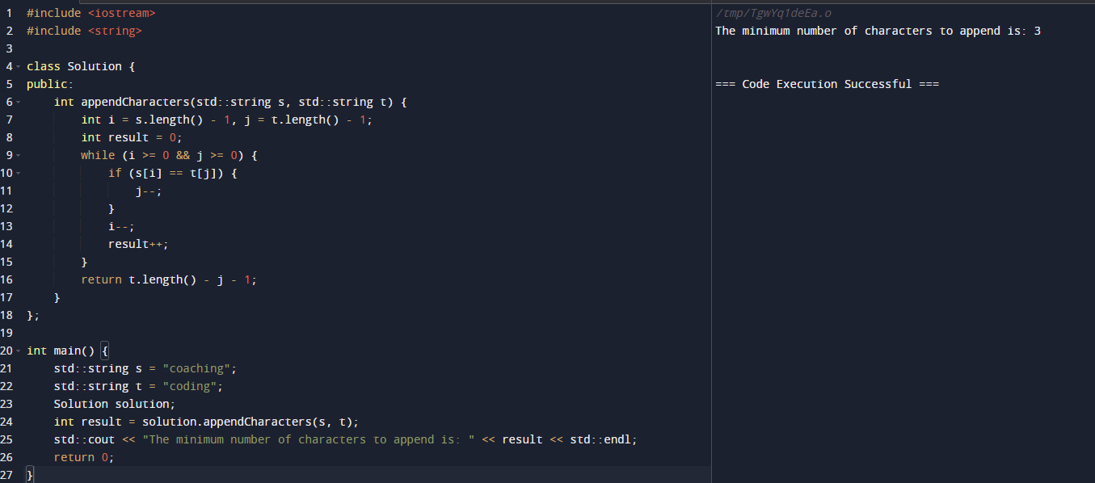

9. Remove Nodes from Linked List

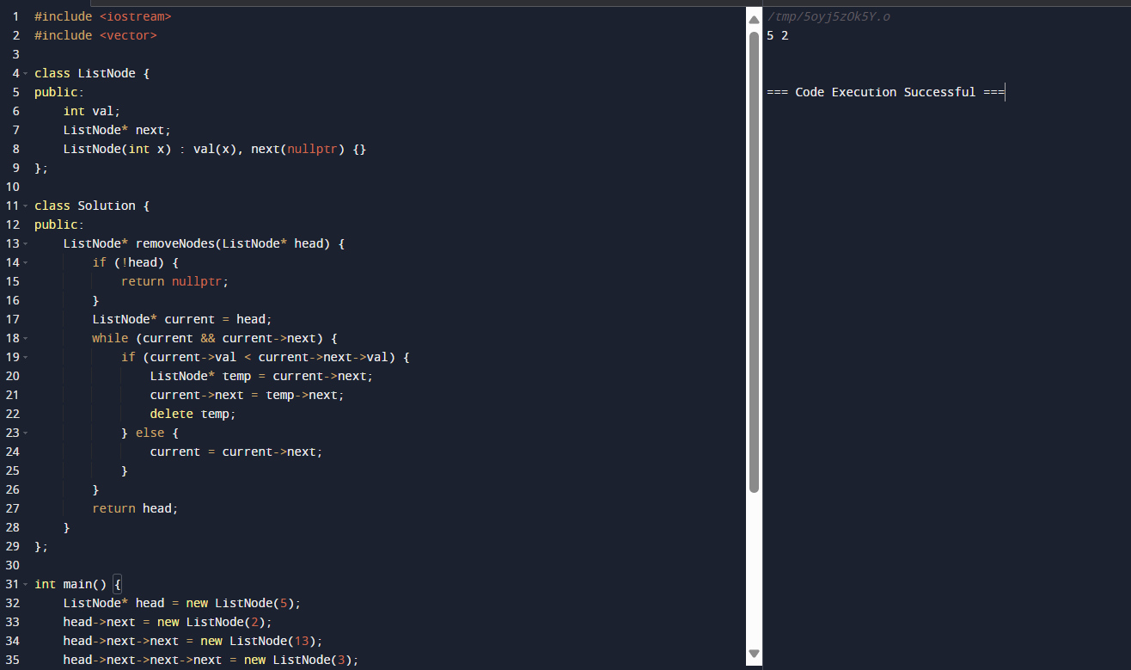

10. Count Subarrays with Median K

